Wp 1
Wp 2
Wp3
Wp 4
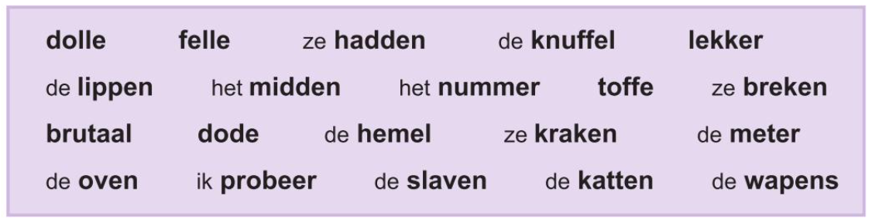

Wp 5
Wp 6
Wp 7
Wp 8

Wp 9
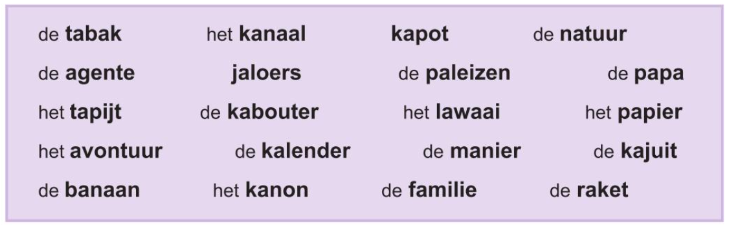
Wp 10
Wp 11
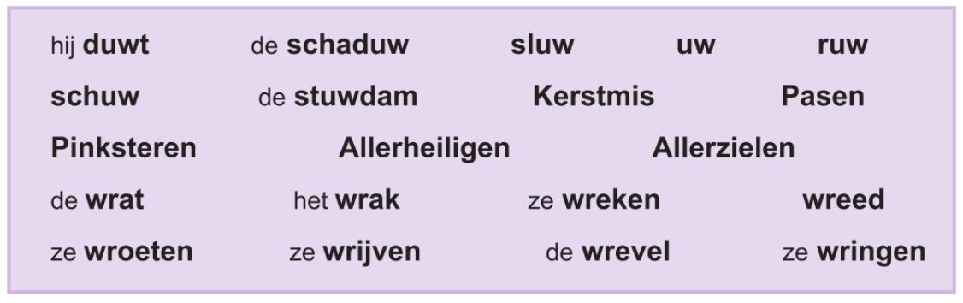
Wp 12
Wp 13
Wp 14
Wp 15
Wp 16
Wp 17
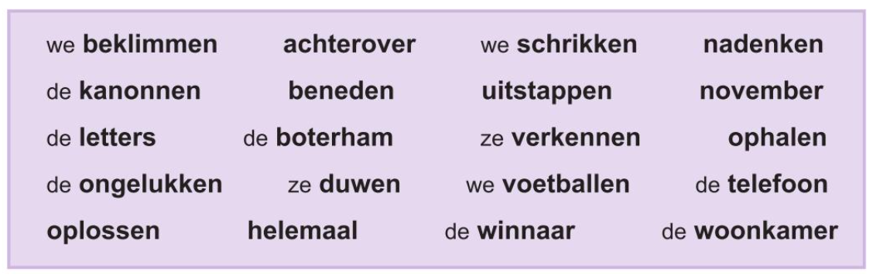
Wp 18
Wp 19
Wp 20
Wp 21
Wp 22
Wp 23

Wp 24
Wp 25
Wp 26
Wp 27
Wp 28
